**The Bash Shell**

## Accessing the AWS Management Console

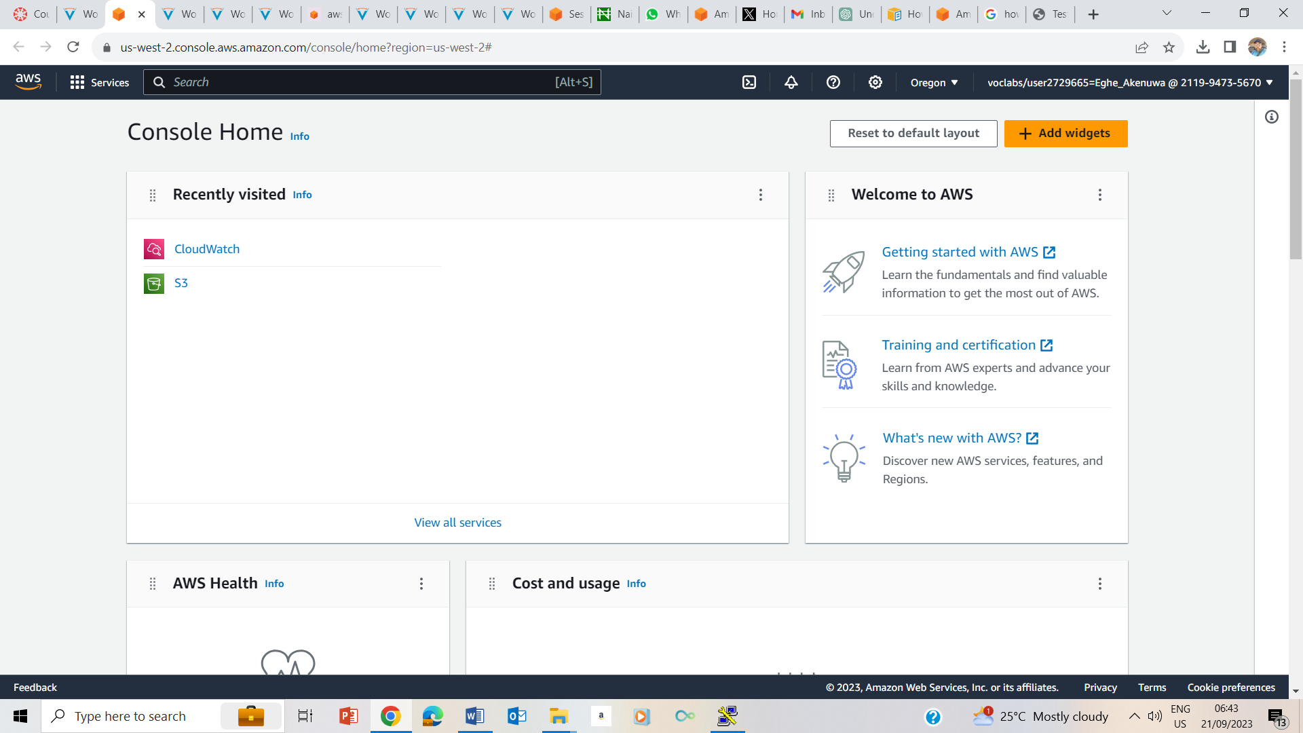

## Task 1: Use SSH to connect to an Amazon Linux EC2 instance

### Windows Users: Using SSH to Connect

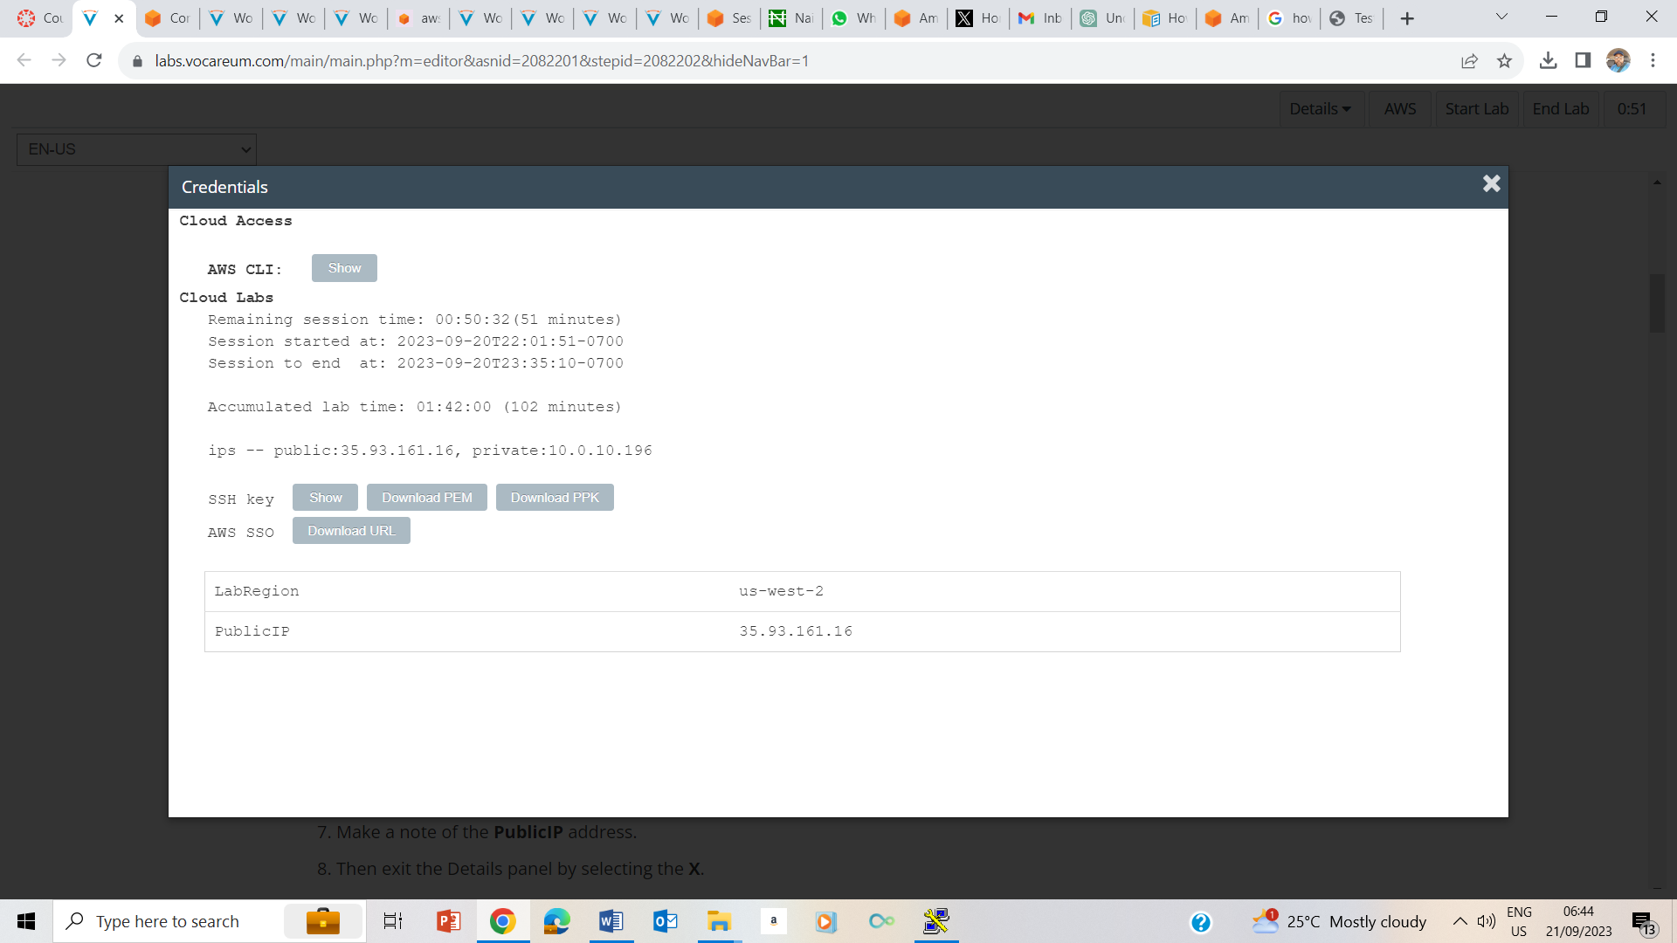

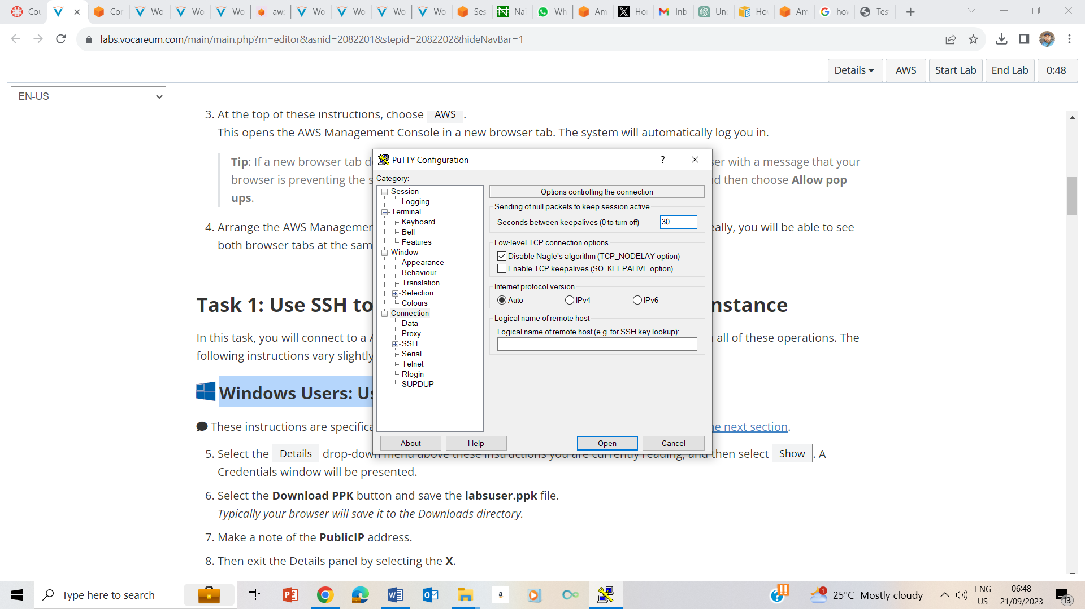

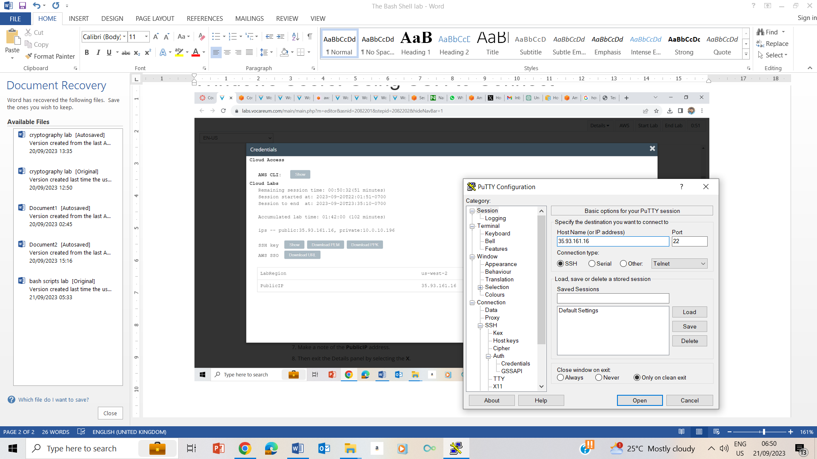

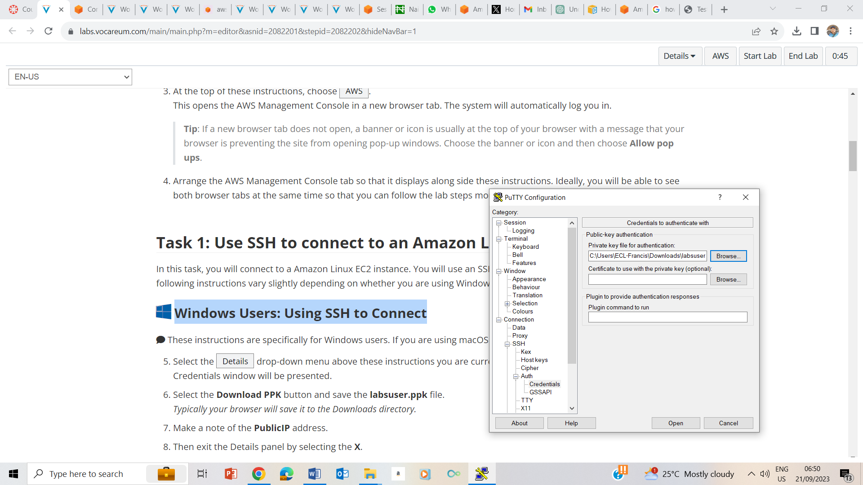

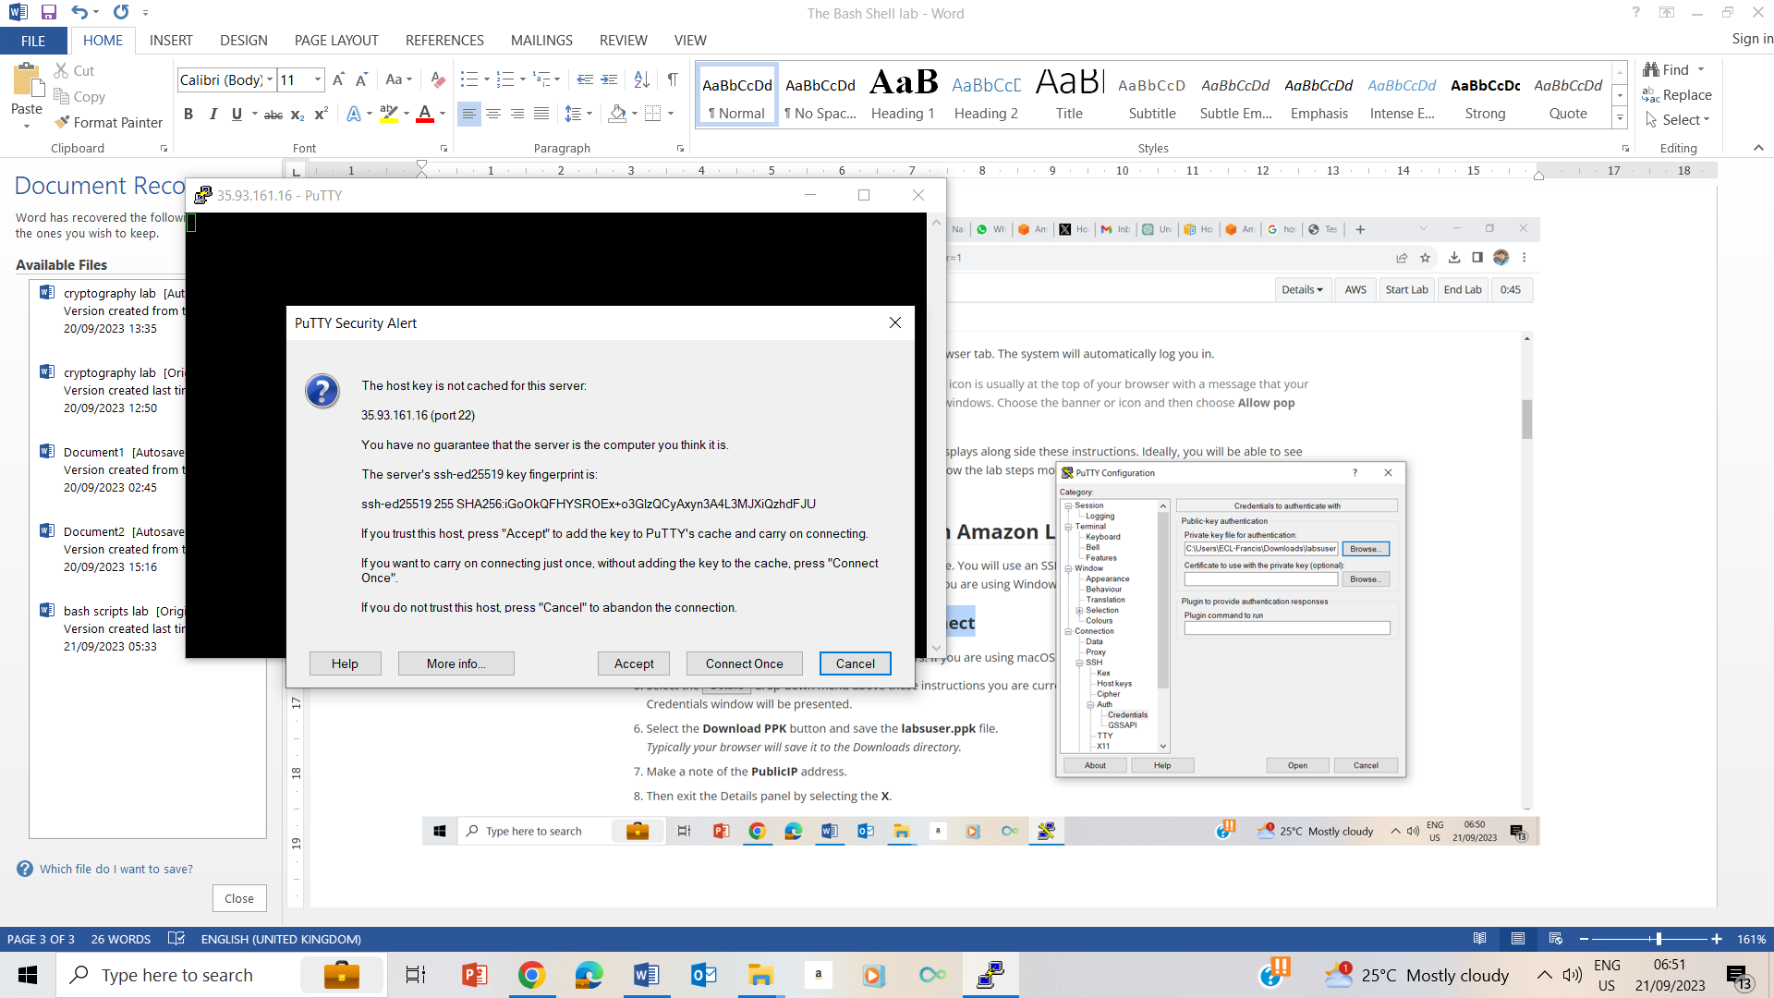

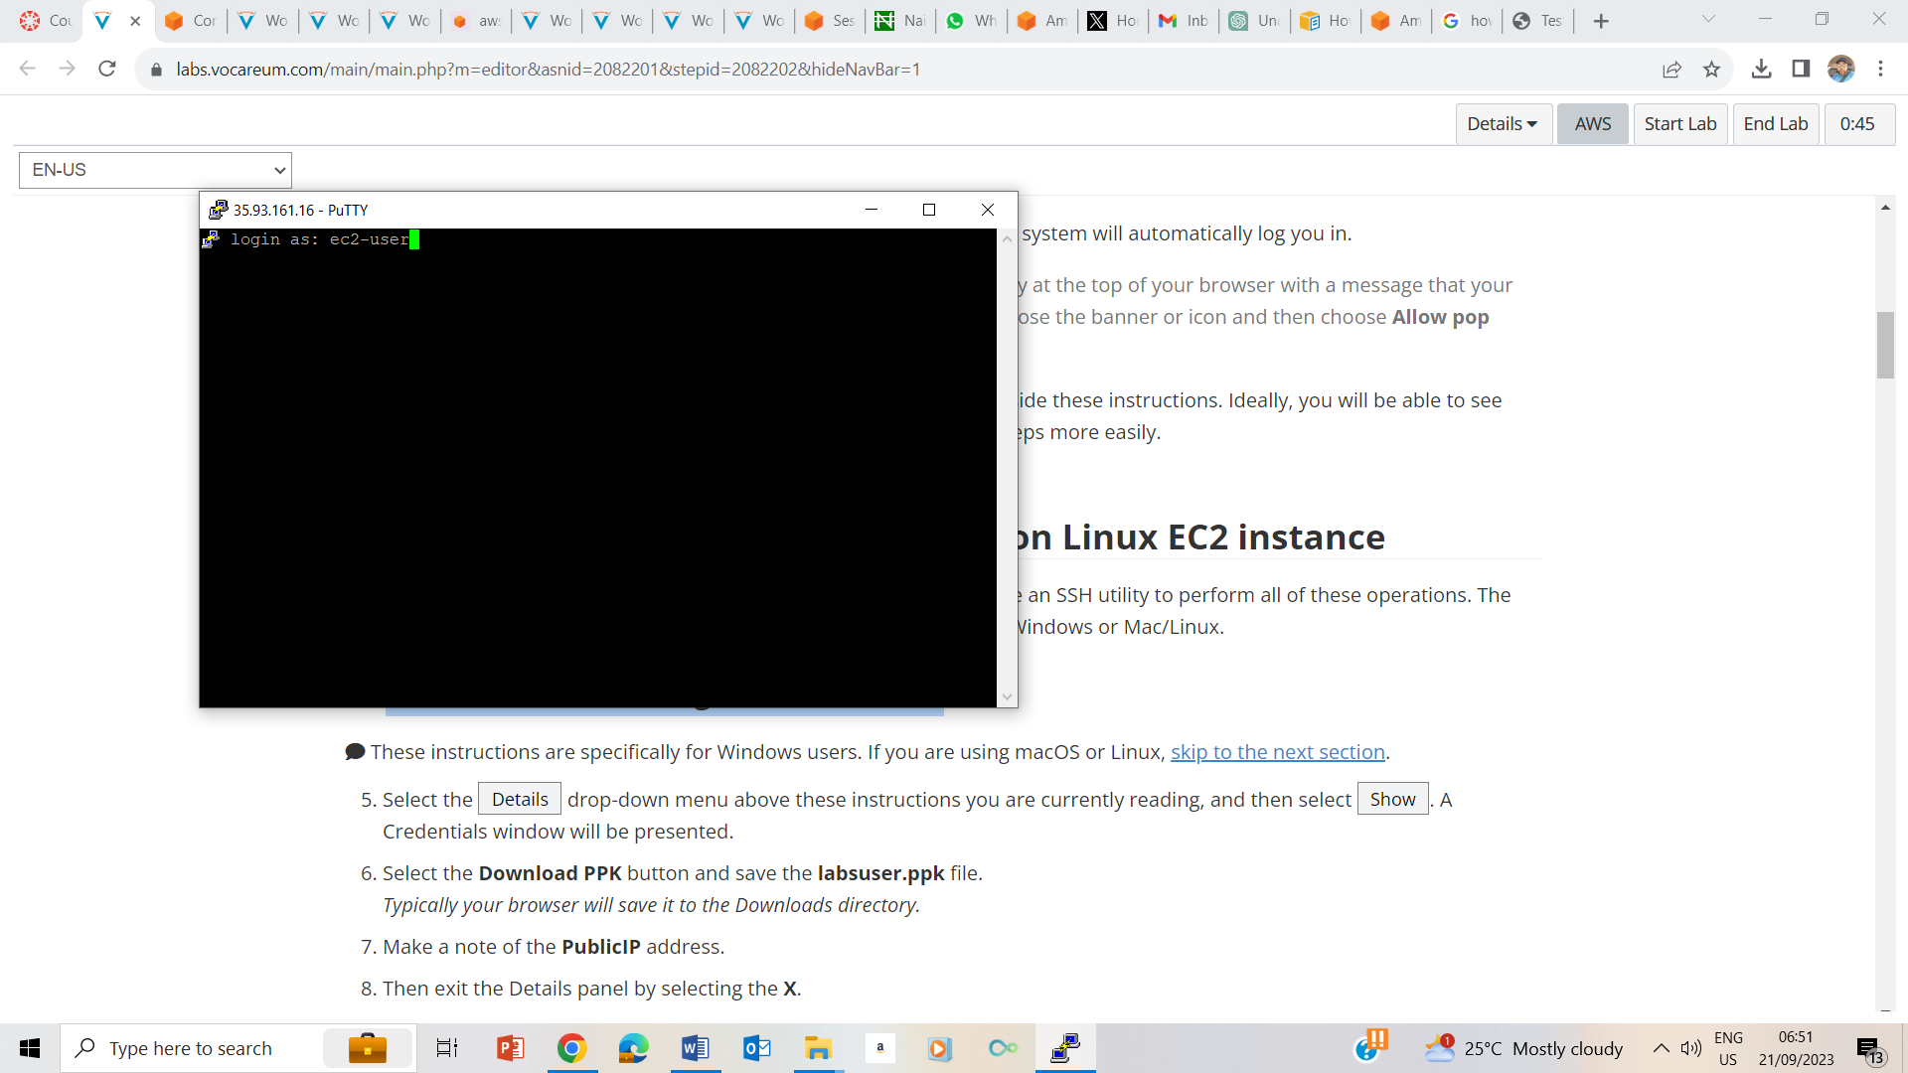

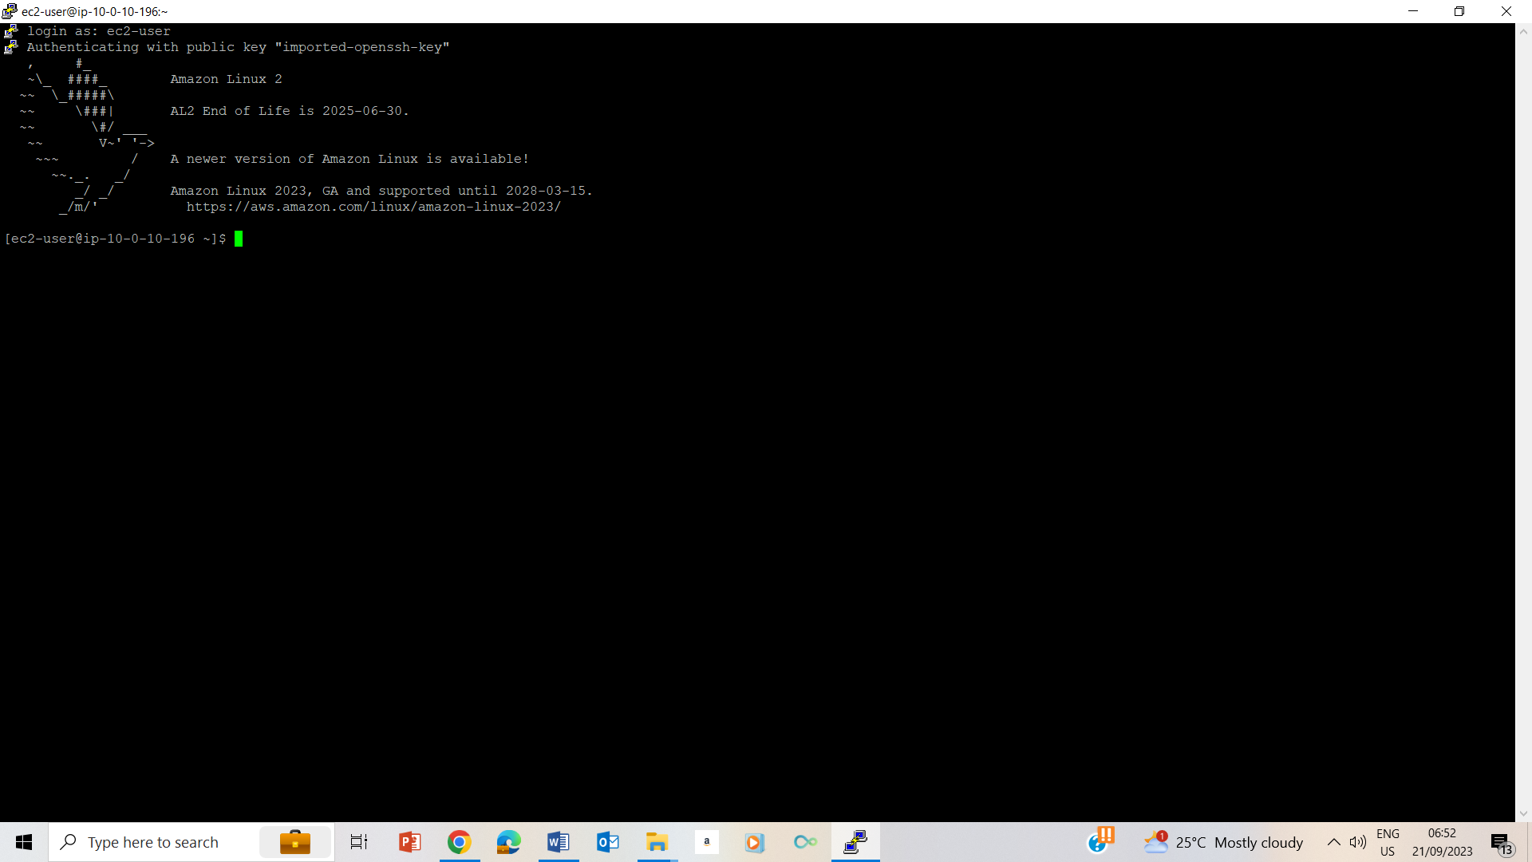

## Task 2: Create an alias for a backup operation

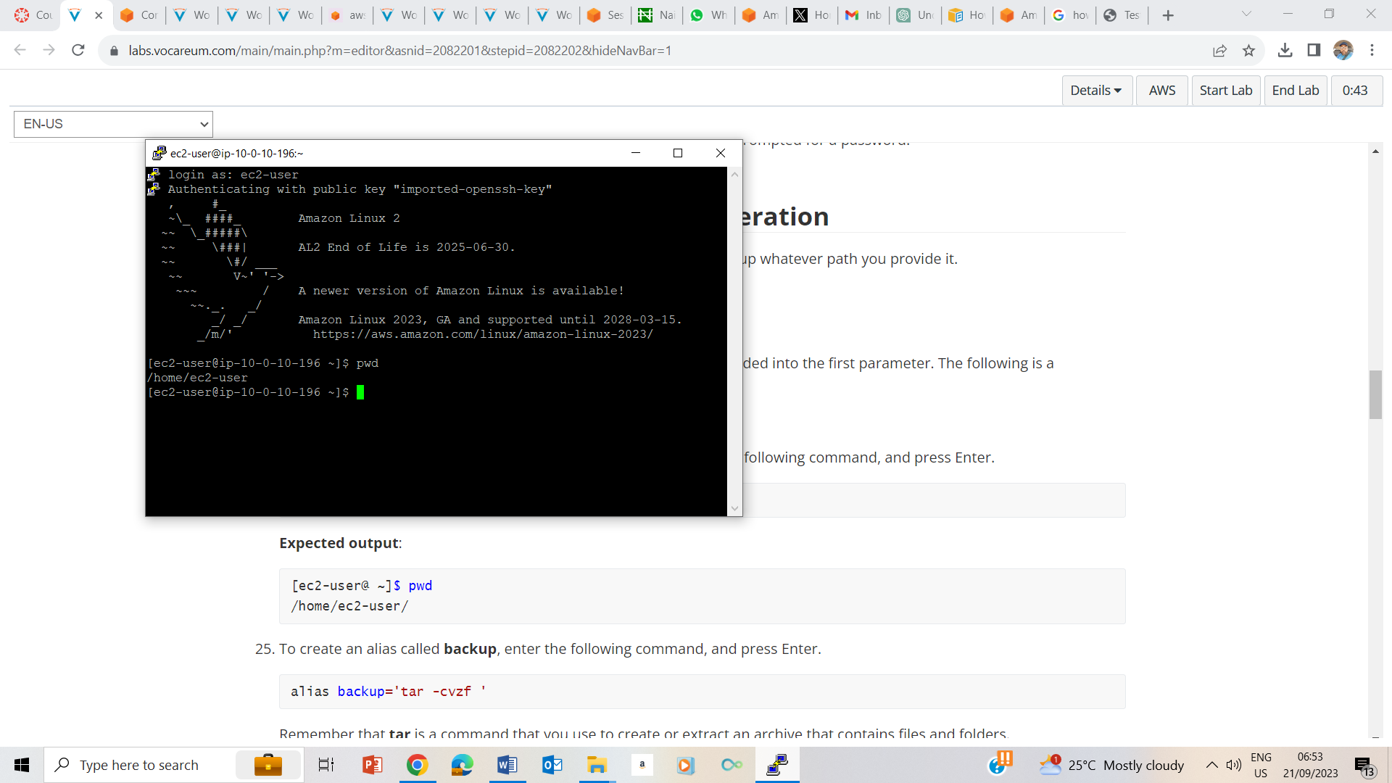

24. pwd to confirm that I am on the /home/ec2-user folder

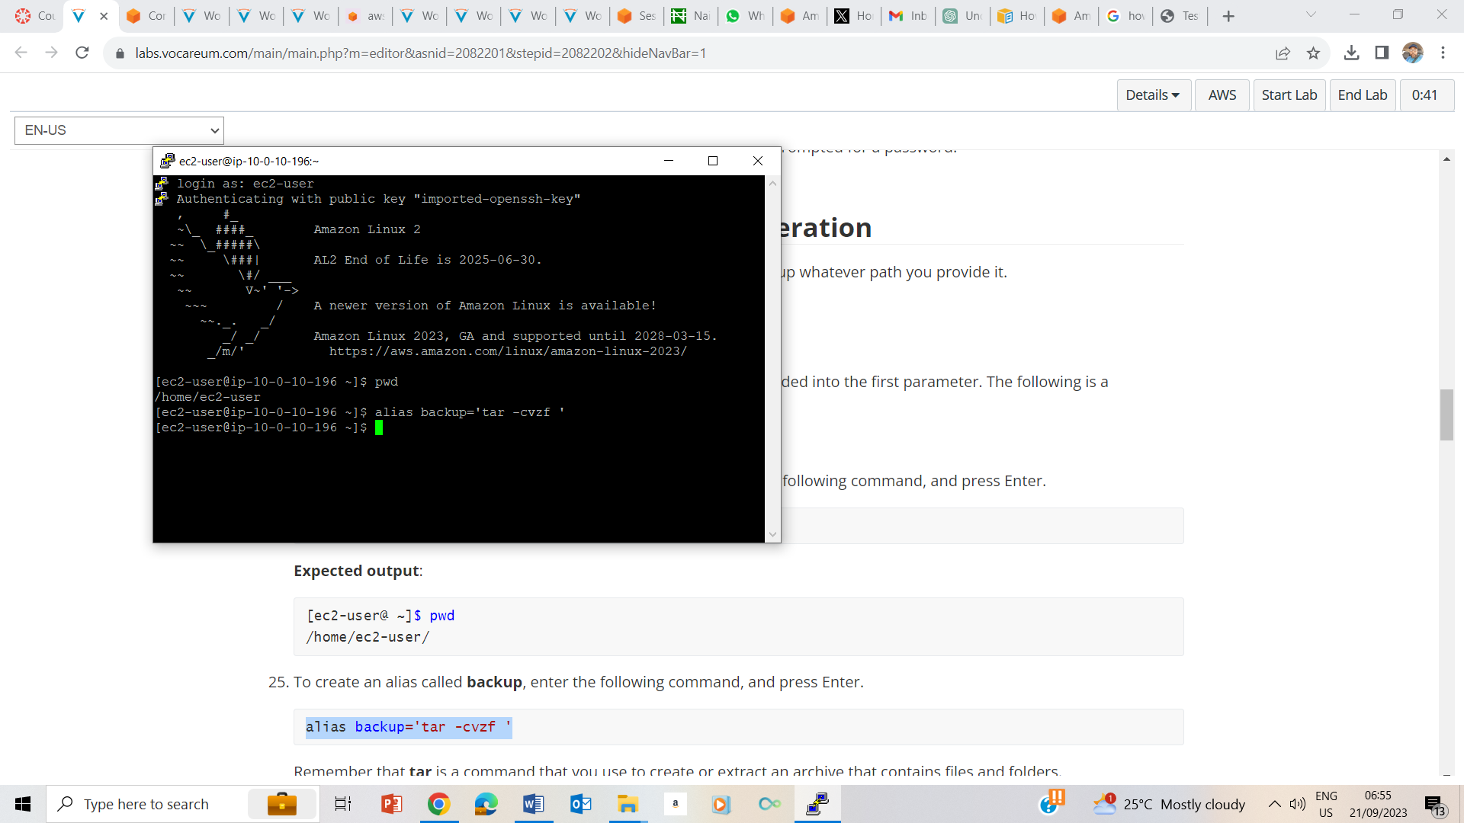

25. creating an alias backup

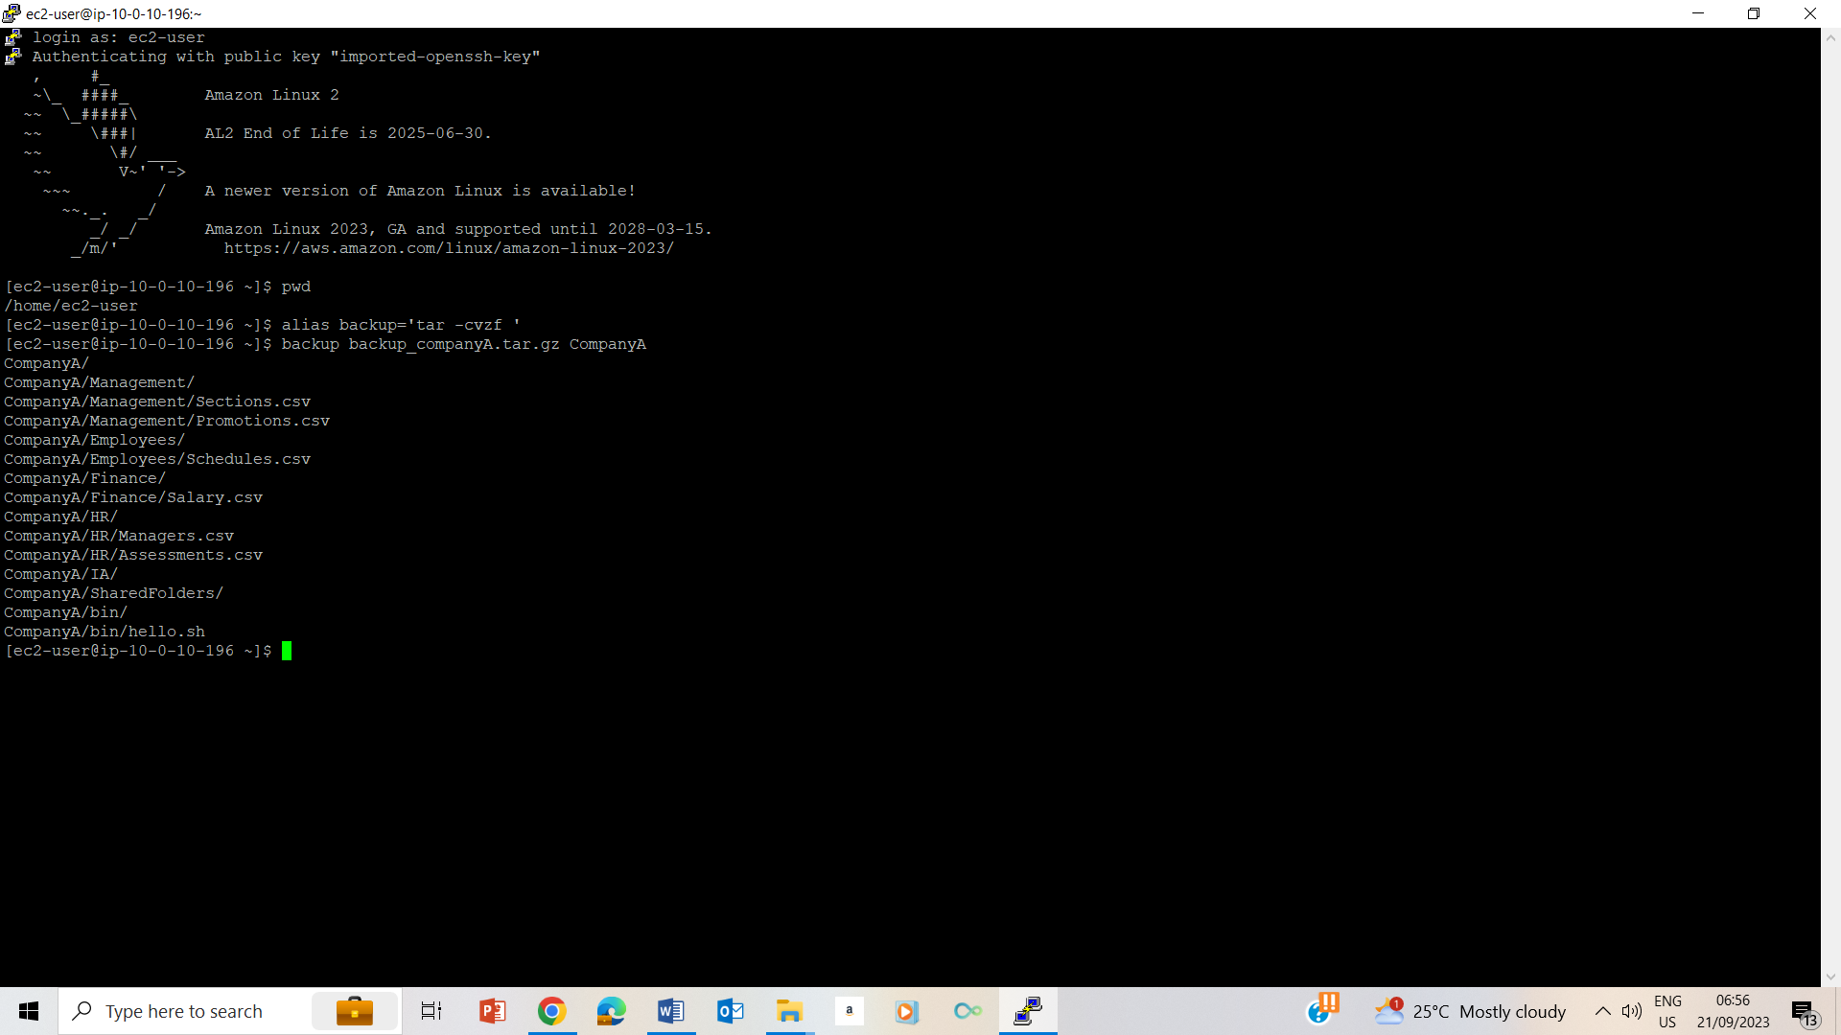

26. Use backup alias to backup CompanyA

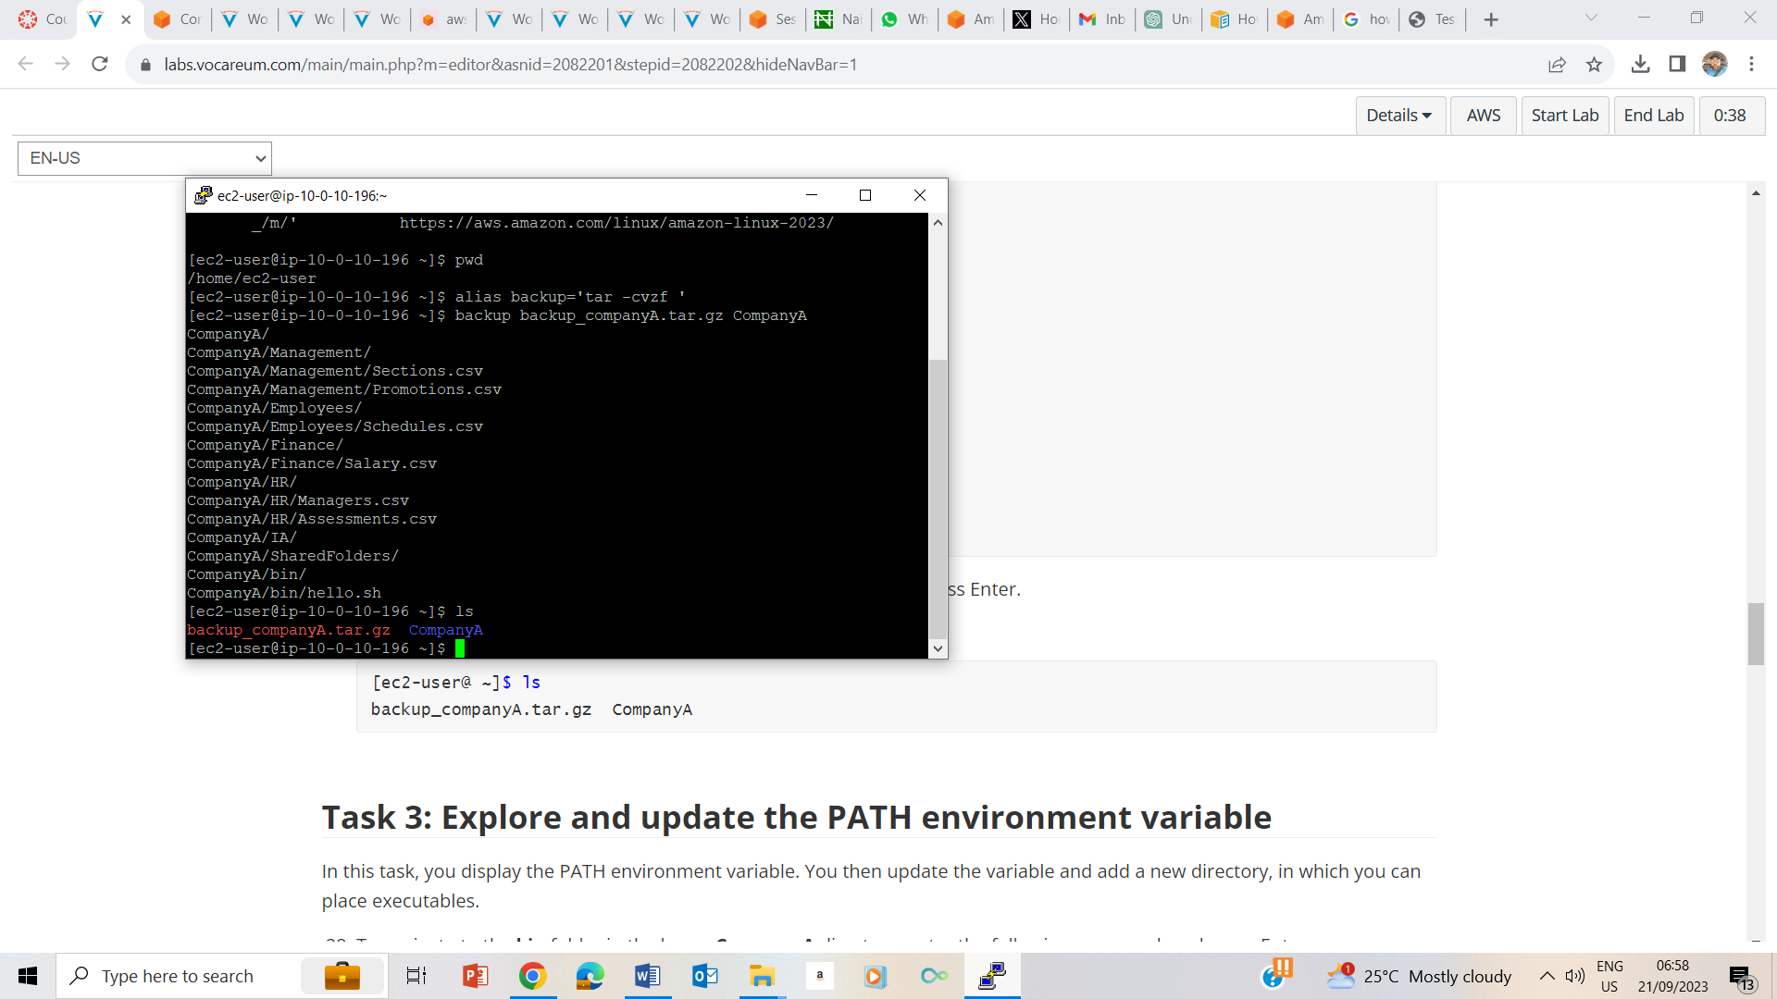

27. ls to show that the CompanyA is backed up

## Task 3: Explore and update the PATH environment variable

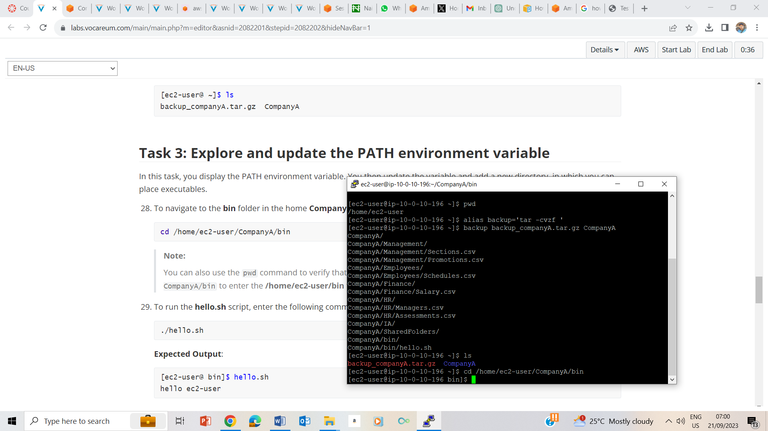

28. Navigate to the bin folder in the home directory of CompanyA

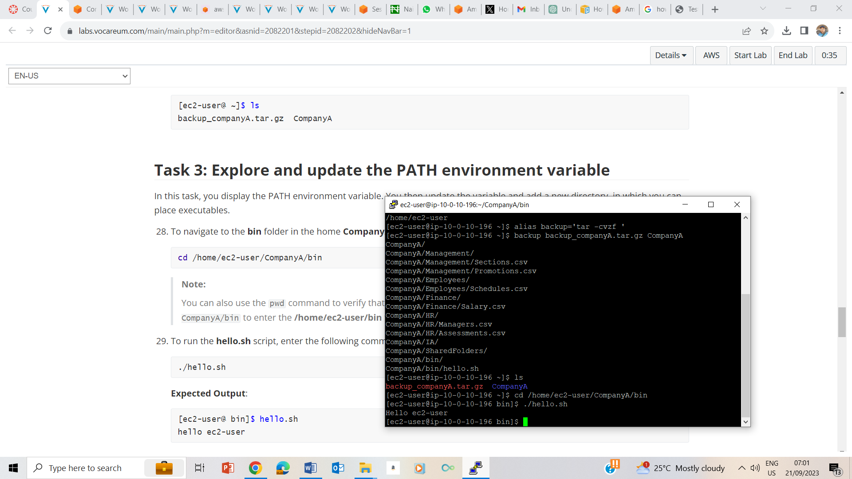

29. running hello.sh script

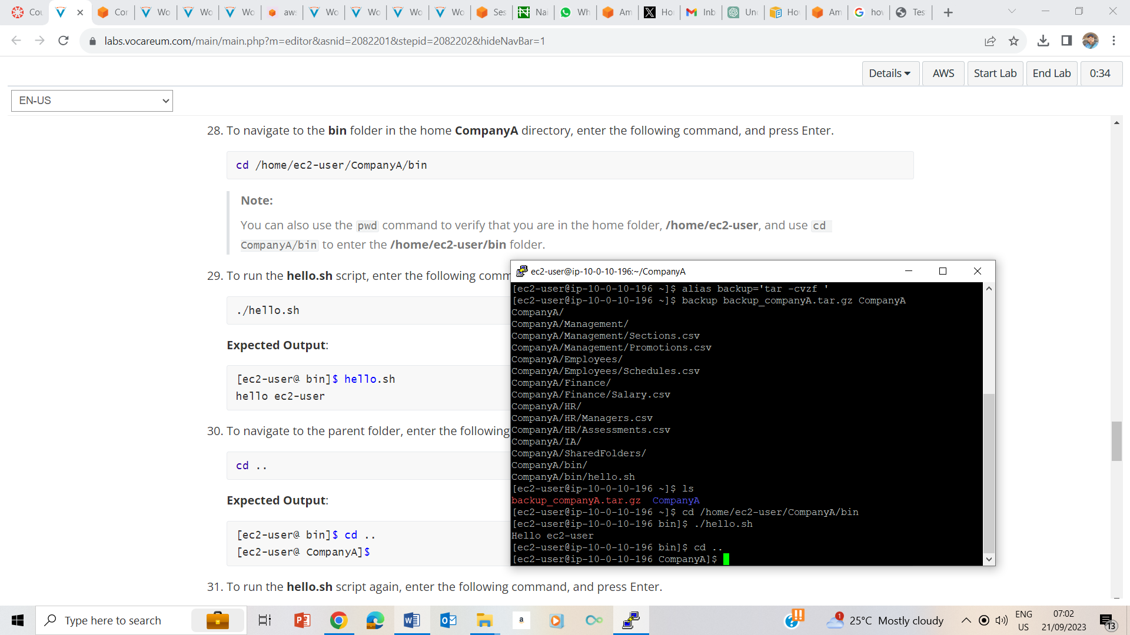

30. Navigating to the parent folder using cd..

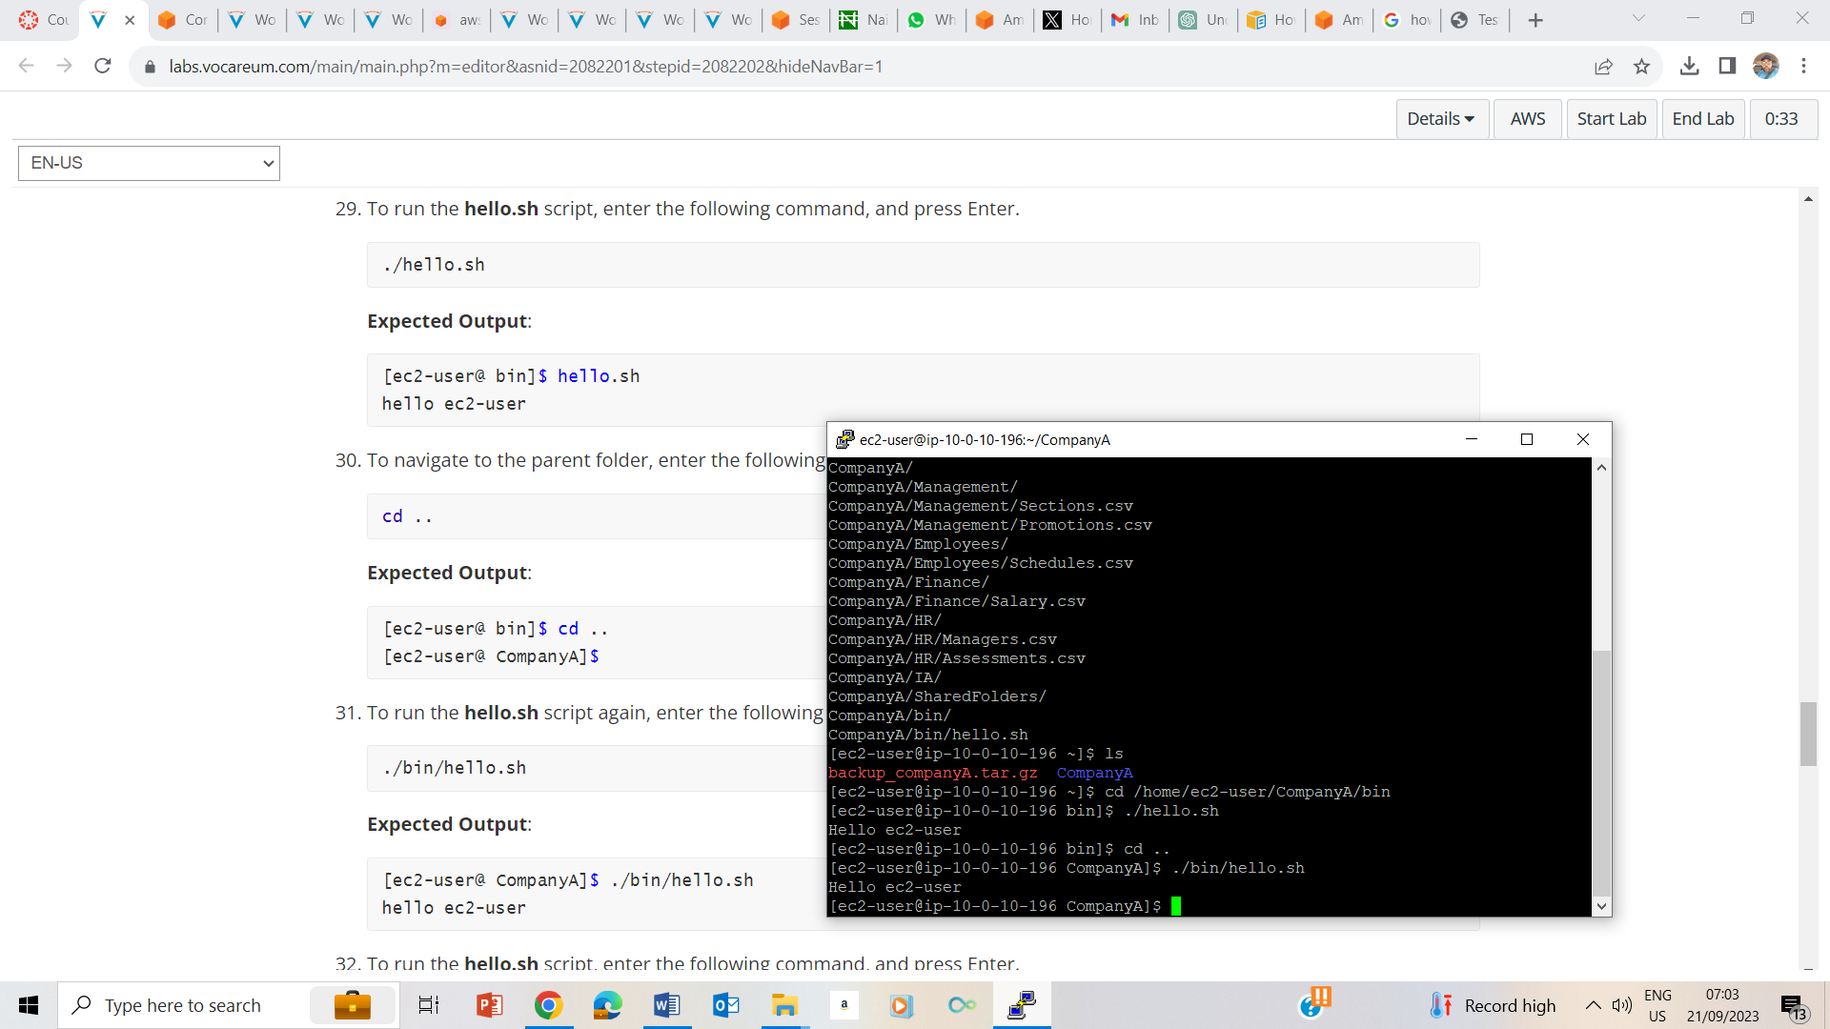

31. running the hello.sh script again

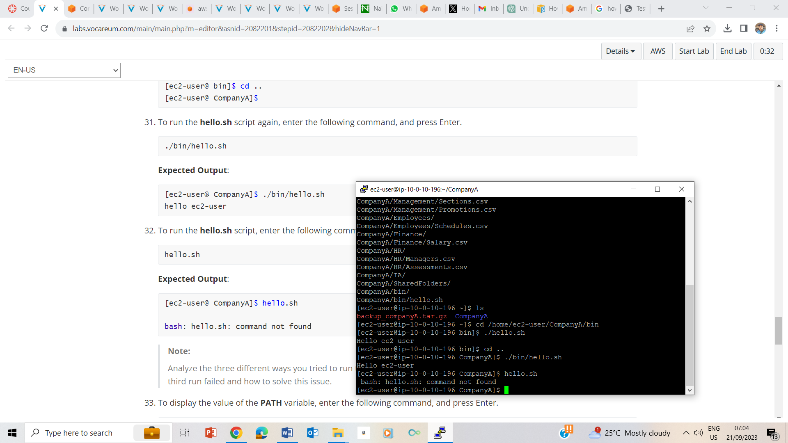

32. running hello.sh, showing command not found

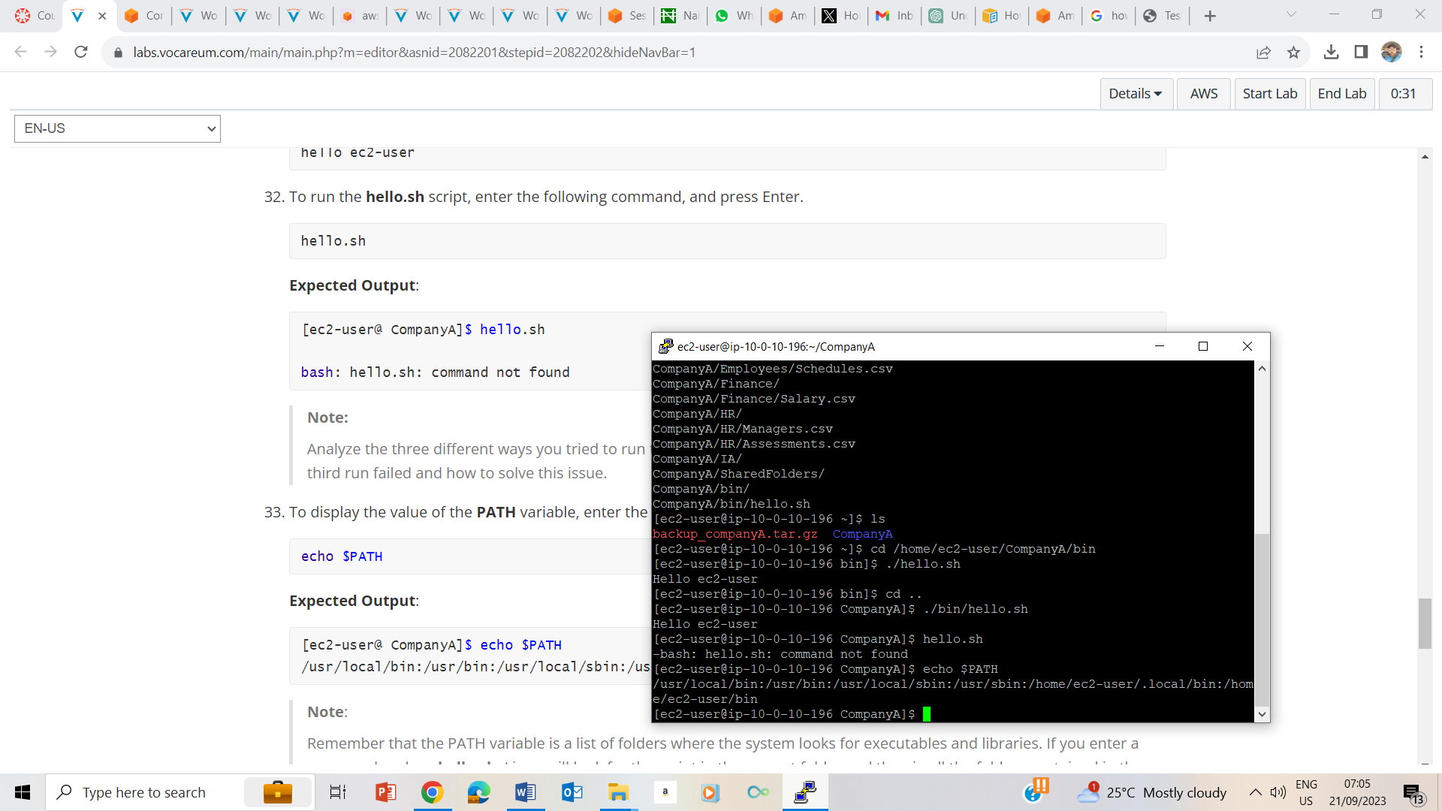

33. echo $PATH

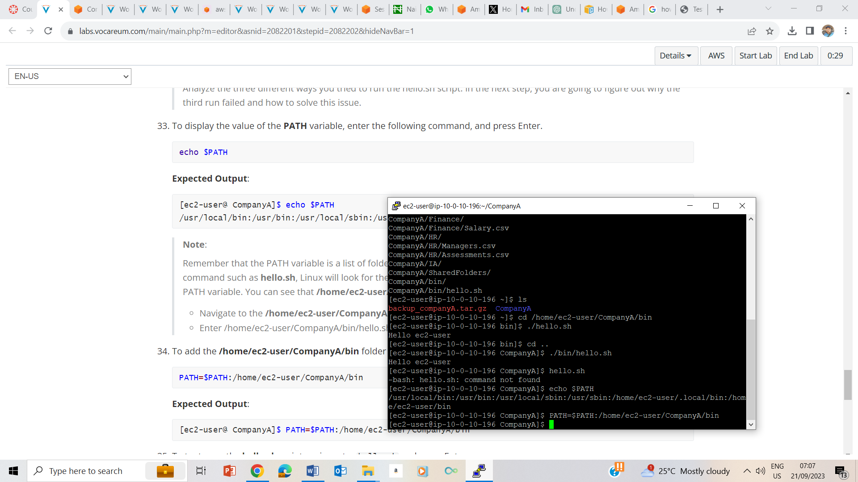

34. adding /home/ec2-user/companyA/bin folder to the PATH variable.

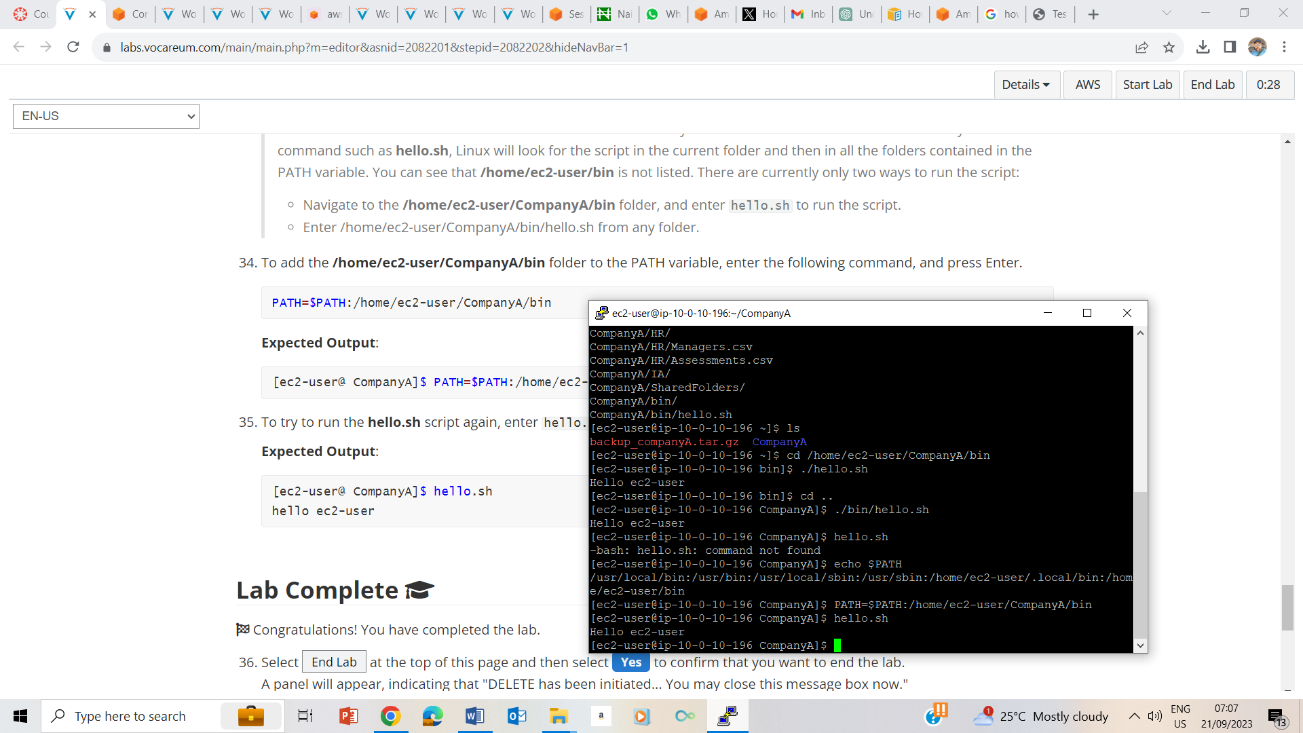

35. running heelo.sh script with the command hello.sh and resulting in hello ec2-user

## Lab Complete

